Head

🔹 What is Head
# Source: AI Source: Provided by: [Data Path: Persons Table -> ID Column: 1, Name_En Column: Motasem Essam] -> From: [Chatgpt (GPT-4-turbo)] on [8/3/2025]
In grammar, the head is the central or core word of a phrase that determines the phrase’s grammatical type and controls its syntactic function in a sentence.
🧠 Every phrase has a head, and the phrase takes its name and function from it.
For example, in a noun phrase, the head is a noun.

✅ General Structure of Phrases:
# Source: AI Source: Provided by: [Data Path: Persons Table -> ID Column: 1, Name_En Column: Motasem Essam] -> From: [Chatgpt (GPT-4-turbo)] on [8/3/2025]
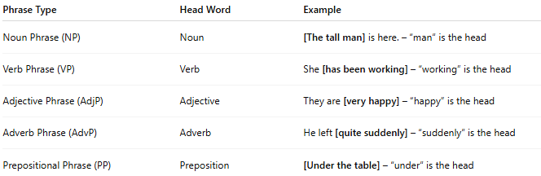
Phrase Type | Head Word | Example
Noun Phrase (NP) | Noun | [The tall man] is here. – “man” is the head
Verb Phrase (VP) | Verb | She [has been working] – “working” is the head
Adjective Phrase (AdjP) | Adjective | They are [very happy] – “happy” is the head
Adverb Phrase (AdvP) | Adverb | He left [quite suddenly] – “suddenly” is the head
Prepositional Phrase (PP) | Preposition | [Under the table] – “under” is the head

✅ Function of the Head:
# Source: AI Source: Provided by: [Data Path: Persons Table -> ID Column: 1, Name_En Column: Motasem Essam] -> From: [Chatgpt (GPT-4-turbo)] on [8/3/2025]
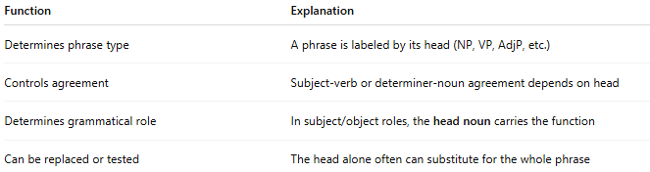
Function | Explanation
Determines phrase type | A phrase is labeled by its head (NP, VP, AdjP, etc.)
Controls agreement | Subject-verb or determiner-noun agreement depends on head
Determines grammatical role | In subject/object roles, the head noun carries the function
Can be replaced or tested | The head alone often can substitute for the whole phrase

✅ Examples by Phrase Type:

🔹 Noun Phrase (NP)
# Source: AI Source: Provided by: [Data Path: Persons Table -> ID Column: 1, Name_En Column: Motasem Essam] -> From: [Chatgpt (GPT-4-turbo)] on [8/3/2025]
- The clever boy solved the puzzle.
→ “boy” is the head; the phrase is a noun phrase.

🔹 Verb Phrase (VP)
# Source: AI Source: Provided by: [Data Path: Persons Table -> ID Column: 1, Name_En Column: Motasem Essam] -> From: [Chatgpt (GPT-4-turbo)] on [8/3/2025]
- She is singing loudly.
→ “singing” is the head; auxiliary verbs help complete the VP.

🔹 Adjective Phrase (AdjP)
# Source: AI Source: Provided by: [Data Path: Persons Table -> ID Column: 1, Name_En Column: Motasem Essam] -> From: [Chatgpt (GPT-4-turbo)] on [8/3/2025]
- That’s very unusual.
→ “unusual” is the head; “very” is a modifier.

🔹 Adverb Phrase (AdvP)
# Source: AI Source: Provided by: [Data Path: Persons Table -> ID Column: 1, Name_En Column: Motasem Essam] -> From: [Chatgpt (GPT-4-turbo)] on [8/3/2025]
- He ran too fast.
→ “fast” is the head; “too” modifies it.

🔹 Prepositional Phrase (PP)
# Source: AI Source: Provided by: [Data Path: Persons Table -> ID Column: 1, Name_En Column: Motasem Essam] -> From: [Chatgpt (GPT-4-turbo)] on [8/3/2025]
- He hid behind the curtain.
→ “behind” is the head (preposition); “the curtain” is the complement.

✅ Head vs. Modifier vs. Complement:
# Source: AI Source: Provided by: [Data Path: Persons Table -> ID Column: 1, Name_En Column: Motasem Essam] -> From: [Chatgpt (GPT-4-turbo)] on [8/3/2025]
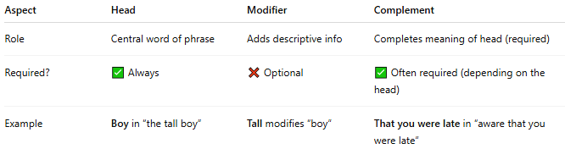
Aspect | Head | Modifier | Complement
Role | Central word of phrase | Adds descriptive info | Completes meaning of head (required)
Required? | ✅ Always | ❌ Optional | ✅ Often required (depending on the head)
Example | Boy in “the tall boy” | Tall modifies “boy” | That you were late in “aware that you were late”

✅ Visual Breakdown:
# Source: AI Source: Provided by: [Data Path: Persons Table -> ID Column: 1, Name_En Column: Motasem Essam] -> From: [Chatgpt (GPT-4-turbo)] on [8/3/2025]
Noun Phrase Example: “The extremely tired little girl”
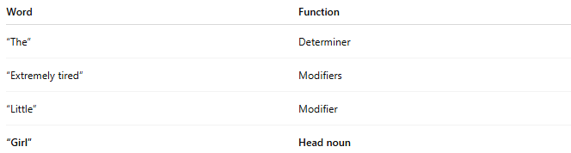
Word | Function
“The” | Determiner
“Extremely tired” | Modifiers
“Little” | Modifier
“Girl” | Head noun

✅ Summary:
# Source: AI Source: Provided by: [Data Path: Persons Table -> ID Column: 1, Name_En Column: Motasem Essam] -> From: [Chatgpt (GPT-4-turbo)] on [8/3/2025]
- The head is the most important word in a phrase.
- It determines the phrase type, governs grammatical agreement, and anchors the structure.
- All phrases — NP, VP, AdjP, AdvP, PP — have heads.
- Heads can be expanded with modifiers and completed with complements.

